** **

**COMSATS University Islamabad, Lahore Campus**

**Sessional Examination II – FALL 2020**

|  |  |  |  |  |  |  |  |  |  |  |
| --- | --- | --- | --- | --- | --- | --- | --- | --- | --- | --- |
| Course Title: | Data Computer Communication and Networks | | | | Course Code: | | CSC339 | Credit Hrs: | | 3(2,1) |
| Instructor/s: | Dr. Muhammad Hasanain Chaudary | | | | Programme Name: | | BS Software Engineering | | | |
| Semester: | **5TH** | Batch: | **FA18-BSE** | Section: | **B** | | Date: | | 5 December 2020 | |
| **Time Allowed:** | **120 Minutes** | | | | **Maximum Marks:** | | | | **35** | |
| Student’s Name: | **Hanzala** | | | | Reg. No. | FA18-BSE-**037** | | | | |
| **Important Instructions / Guidelines:**   * These instructions must be followed strictly. Failure to do so may result in serious grade loss. * You are not allowed to:   + Talk to anyone once the exam begins.   + Think in the air or see here and there. * Keep your eyes on your own paper. * Write your answers only in the space provided against each question and write legibly to get any credit. * No electronic device is allowed (including calculators and cell phones). * Manage time properly and try to attempt easy problems first. | | | | | | | | | | |

|  |  |  |
| --- | --- | --- |
| **Question No.** | **Obtained Marks** | Maximum Marks |
| 1 |  | 15 |
| 2 |  | 10 |
| 3 |  | 10 |
| Total |  | 35 |

**Question # 1: Provide short answers to the questions below: [2+2+2+3+2+4 = 15]**

1. **Suppose the CERN research institute has developed some new technology related to dark matter. They are to share the results with other research institutes. Assume that all of the research institutes are using IPv6. In the world, where IPv4 is most commonly used, how a datagram will move from source to destination. Which concept would be used and explain how it will work? [2]**

|  |
| --- |
| The data will move through tunneling.  For CERN to communicate with its research centers via IPV6, it needs some tunneling techniques. They have two options:  **1) Manual Tunnels**  **2) general orientation packaging.**  In these technologies, IPV6 is encapsulated inside IPV4 and translated using NAT. |

1. **Consider a scenario where there are two hosts, A and B, who are communicating with each other through the use of TCP. Imagine that host A begins the transmission with some data which has small sized segments initially. In your opinion, is this a wise move in sending segments of small size over the network or not. Defend your answer with the proper method involved. [2]**

|  |
| --- |
| If very small segments of TCP are sent over IP, it creates a lot of **overhead**. This results in **inefficient** use of **bandwidth**. However, we cannot increase the size much, since the network layer will be fragmented, since this layer has its own size limit. For this reason, we have set the Maximum Segment Size **(MSS)**. |

1. **Considering the same scenario as of part b, after the initial sending of small sized segments, the rate of transmission is increased by the host A. This would result in host A sending a continuous amount of large data to host B. In your opinion, how will host B manage such large amount of data. Is there a possibility that the data being received at host B overflows which could result in data loss? [2]**

|  |
| --- |
| Congestion might occur because too large number of source sending too large amounts of data. This results in   1. Poor utilization of resource because of dropped packets. 2. Retransmitions 3. Poor resource allocation. |

1. **Suppose you are assigned as a network administrator of a large and complex network of a multi-city bank. How will you manage the whole network? Will you try to completely handle all of the networks (of every city) by yourself? If not, how will you handle the situation. Also list whether link state or distance vector routing algorithms will be used as per your answer. [3]**

|  |
| --- |
| As a network administrator, I am responsible for the daily operation and maintenance of the network. For network design, I'll hire a network engineer. Since our organization is large, I will use link-state routing protocols. Although difficult to maintain and troubleshoot, our network will become more efficient and thus worth the effort. |

1. **Suppose there is a tree-based network present which was constructed through the source node. Imagine a message is broadcasted across the network. In your opinion, what are the approaches which can be used to avoid a broadcasting storm. [2]**

|  |
| --- |
| In order to avoid a broadcast storm in a tree network, we can use the Spanning Tree Protocol (**STP**) or the Rapid Spanning Tree Protocol (**RSTP**), depending on the availability of support.  Some approaches are:  1- Check for loops in switches.  2- Split up broadcast domain.  3- Storm control and equivalent protocols.  4- Ensure IP-directed broadcasts are disabled on Layer three devices. |

1. **Suppose two hosts (A & B) are communicating with each using TCP. However, during the transmission of data, the network experiences difficulties in the handling of data. This issue pertains to the fact that other hosts besides A and B also start transmitting data which results in packet loss and an increased end-to-end delay. What is this phenomenon called and how does TCP avoid such an issue? [4]**

|  |
| --- |
| TCP is a reliable, connection-dependent protocol. This means that if a packet is lost, TCP will scan for the lost packets and request them again. Sending too much data through a network is difficult to handle resulting in data loss and delay. This phenomenon is called Congestion. TCP avoid this issue by using a mechanism called **Congestion Control**. A congestion window is used to limit the number of bytes being sent through TCP. It starts by sending a packet to receiver. Then waits for receiver to send acknowledgement. Once it is received, sender starts sending packets and ack. is received for each. The number of packets grow exponentially until the limit of congestion window is met. After that it again starts linear growth to control congestion. |

**Question 2: Considering the scenario given below, you are to perform Variable length subnet masking and present answers to the following [10]**

1. **Present how many subnets would be required for the network [3]**
2. **What is the CIDR or subnet mask of the provided IP address block [3]**
3. **List down all of the subnet range along with their network and broadcast ID. [4]**

**The block of IP address that you are provided is 152.16.0.0/16. Also assume that each switch is further connect to 40-50 PCs of varying amount.**

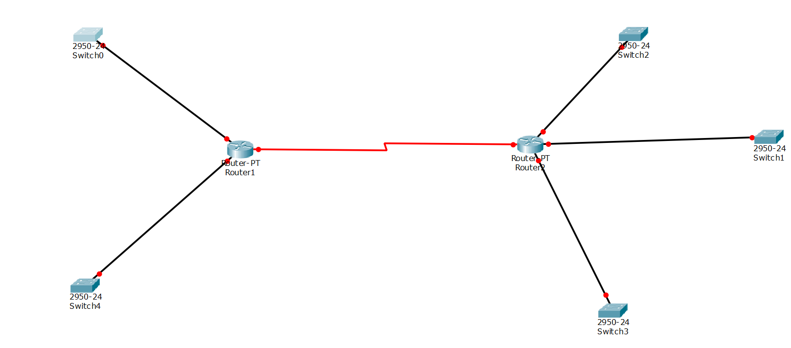

**A)**

**1)**

IP: 152.16.0.0

Class B

Max hosts = 50

**2)**

2^n - 2>= 50

2^6 - 2 = 62

n = 6

**B)**

**CIDR -> 255.255.255.192/26**

**C)**

**Subnet 1**

Hosts -> 41 | n -> 64

Network IP -> 152.16.0.0/26

Broadcast IP -> 152.16.0.63/26

Range -> 152.16.0.1 <-> 152.16.0.62

**Subnet 2**

Hosts -> 42 | n -> 64

Network IP -> 152.16.0.64/26

Broadcast IP -> 152.16.0.127/26

Range -> 152.16.0.65 <-> 152.16.0.126

**Subnet 3**

Hosts -> 43 | n -> 64

Network IP -> 152.16.0.128/26

Broadcast IP -> 152.16.0.191/26

Range -> 152.16.0.129 <-> 152.16.0.190

**Subnet 4**

Hosts -> 44 | n -> 64

Network IP -> 152.16.0.192/26

Broadcast IP -> 152.16.0.255/26

Range -> 152.16.0.193 <-> 152.16.0.254

**Subnet 5**

Hosts -> 45 | n -> 64

Network IP -> 152.16.1.0/26

Broadcast IP -> 152.16.1.63/26

Range -> 152.16.1.1 <-> 152.16.1.62

**Subnet 6**

Hosts -> 1 | n -> 4

Network IP -> 152.16.1.64/26

Broadcast IP -> 152.16.1.67/26

Range -> 152.16.1.65 <-> 152.16.1.66

**Question # 3: Consider the network graph given below. You are to employ either Link State or Distance Vector Routing Algorithms. The decision is completely up to you. Present the complete working of your answer. Assume that R1 is the source and R6 is the destination (in case of LS). [10]**

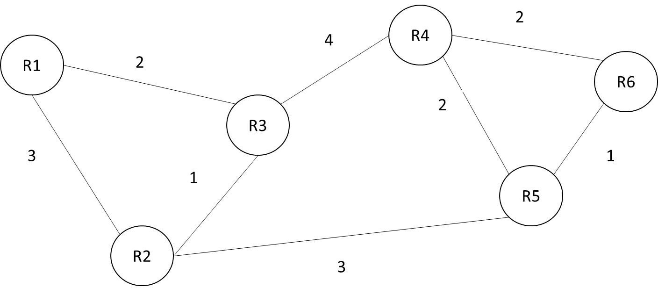

|  |  |  |  |  |  |  |  |
| --- | --- | --- | --- | --- | --- | --- | --- |
| **Step** | **N** | **D(R1)**  **P(R1)** | **D(R2)**  **P(R2)** | **D(R3)**  **P(R3)** | **D(R4)**  **P(R4)** | **D(R5)**  **P(R5)** | **D(R6)**  **P(R6)** |
| 1 | R1 | - | 3, R1 | 2, R1 | ∞ | ∞ | ∞ |
| 2 | R1, R3 | - | 3, R1 | - | 6, R3 | ∞ | ∞ |
| 3 | R1, R3, R2 | - | - | - | 6, R3 | 6, R2 | ∞ |
| 4 | R1, R3, R2, R4 | - | - | - | - | 6, R4 | 8, R4 |
| 5 | R1, R3, R2, R4, R5 | - | - | - | - | - | 7, R5 |
| 6 | R1, R3, R2, R4, R5, R6 | - | - | - | - | - | - |

**Shortest Path:** R1 – R2 – R5 – R6